**RIPHAH INTERNATIONAL UNIVERSITY, ISLAMABAD**



**Lab 2**

**Bachelors of Computer science – 5th semester**

**Subject:** Operating System Lab

**Submitted to:** Ma’am Kausar Nasreen Khattak

**Submitted by:** Munaza Malik

**Sap Id:** 44956

**Date:** 2th September, 2024

**Lab Task**

**Q1.** To begin, you need to set up a structured directory layout in your home directory. Start by creating two directories named **OS_Course** and **OS_Lab**. These directories will serve as the main folders for organizing your OS Lab tasks. After creating these directories, switch to the **OS_Lab** directory. Within OS_Lab, create three more directories named **LAB_Class_Task, LAB_Activities, and Lab_Practice**. Each of these directories will help you categorize different aspects of your lab work. Once you have created these directories, go into the **Lab_Practice** directory and create a file named example.cpp. This file should be empty and will be used for practice later. Finally, move back to your home directory. Make sure to take screenshots of each step, including the creation of directories, the file creation, and your navigation commands to document your process.

**Note:** Include screenshots, where required to illustrate your explanation.

**Solution:**

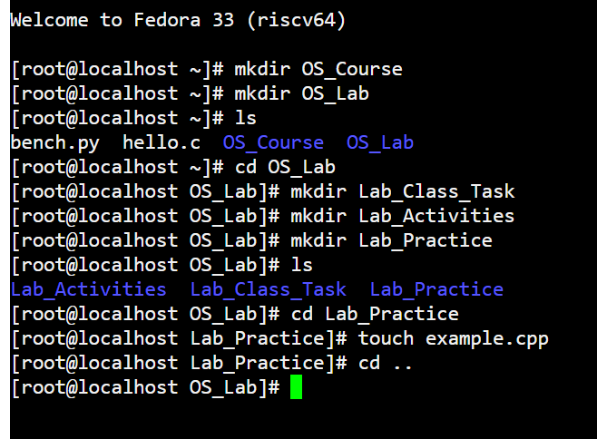

**Q2.** Finally, you need to understand the concepts of absolute and relative paths. Explain the difference between these two types of paths and provide an example of each. This will help you navigate directories more effectively. If you are currently in the Lab_Practice directory, describe the relative path to access the **LAB_Activities** directory. This will test your understanding of how to move between directories using relative paths.

**Note:** Include screenshots, where required to illustrate your explanation.

**Solution:**

**Absolute Path:** An absolute path is the complete path from the root directory to the desired file or directory. It always starts with a / and provides the full location of the file or directory in the system.

**Example:**

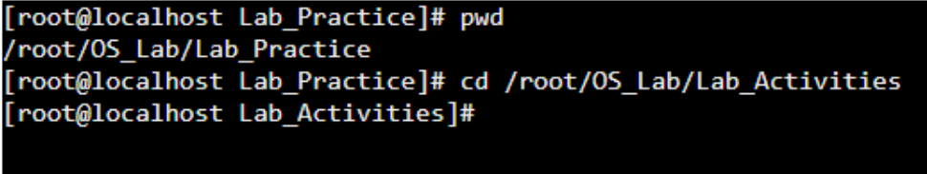

**Relative Path:** A relative path is the path to a file or directory relative to the current directory we are in. It is shorter than an absolute path because it only includes the steps needed to navigate from our current location.

**Example:**

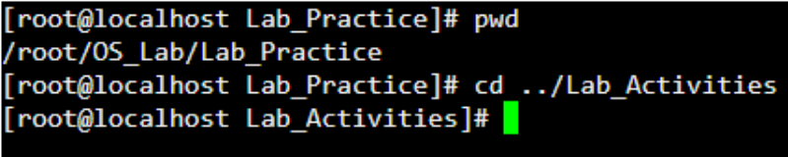

**Q3.** Imagine you’re working on your computer when you suddenly need to turn it off quickly. You press and hold the power button until the computer shuts down completely. After an hour, you turn the computer back on, and it quickly shows the login screen or desktop.

Why does your computer start up smoothly and quickly after being turned off? Describe the process that happens between powering off the computer and seeing the login or desktop screen. What steps does the computer go through to get everything ready in a short amount of time?

**Solution:**

When I power off my computer by pressing and holding the power button, the computer goes through a shutdown process. During this process, the operating system (like Windows or macOS) sends signals to all running programs and services to save their current state and data. Once everything is saved, the operating system instructs the hardware components to power off.

When I turn the computer back on after an hour, the startup process begins. The computer first goes through a **power-on self-test (POST)** where it checks if all the hardware components are functioning correctly. Then, the **BIOS (Basic Input/Output System)** is loaded, which initializes the hardware components like the CPU, RAM, and storage devices.

After the hardware is initialized, the operating system is **loaded** from the storage drive into the computer's memory. Once the operating system is loaded, it starts initializing drivers for the hardware components, loading system services, and launching essential processes.

The reason my computer starts up quickly after being turned off is that when I shut down the computer properly, it saves the system state and doesn't leave any programs or processes running in the background. This clean shutdown allows the computer to start up smoothly and quickly.